
Pre-AP Biology
Unit 1 – Cell Structure and Function
Suggested Duration: 10 Days

CELL STRUCTURE AND FUNCTION
UNIT PLAN

Table of Contents
UNIT NARRATIVE 1
CONTENT STANDARDS 2
UNDERSTANDINGS AND QUESTIONS 2
ROADMAP 3
UNPACKED STANDARDS 14
VERTICAL STANDARDS 17
VOCABULARY GLOSSARY 19

UNIT NARRATIVE
This is the first unit of the year, and it sets the foundation for content/skills needed in subsequent units. Students gain conceptual understanding of the four different biomolecules and how these are utilized by prokaryotic and eukaryotic cells to carry out their functions through the use of a hands-on-minds-on activity involving determination of a murder suspect based on chemical analysis. Students then dig into the plethora of eukaryotic organelles and gain clarity on the richness of the eukaryotic cell itself through computer modeling, creating physical models, and video analysis of real-world applications. This carries into a study of viruses and they compare to living cells through the use of computer simulations and video analysis. Students will be able to compare and contrast how viruses are both similar and different from “living” cells (prokaryotic and eukaryotic).

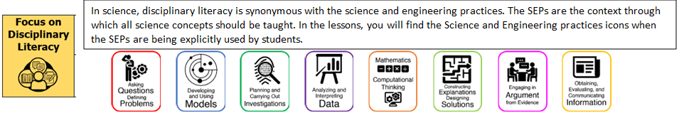

CONTENT STANDARDS
Below are the standards taught and assessed in this unit.
Learning Objectives (Students will be able to…)
Biomolecules
- B.5.A – relate the functions of different types of biomolecules, including carbohydrates, lipids, proteins, and nucleic acids, to the structure and function of the cell
Cell Structure and Function
- B.5.B – compare and contrast prokaryotic and eukaryotic cells, including their complexity, and compare and contrast scientific explanations for cellular complexity
- B.5.D – compare the structures of viruses to cells and explain how viruses spread and cause disease

UNDERSTANDINGS AND QUESTIONS
Important big ideas and processes for the unit.
Enduring Understandings
Students will understand that …
Four classes of macromolecules serve as the primary building blocks of biological systems.
Biological systems have specialized structures that enable specific functions necessary to sustain life.
Biological systems must respond to changes in internal and external environments in order to maintain dynamic homeostasis.

Key Questions
- How do the structures of carbohydrates, lipids, proteins, and nucleic acids resemble each other? How are they different? What is the function of each one?
- What are the differences between prokaryotic and eukaryotic cells?
- What are the eukaryotic organelles and what is the function of each one?
- What is the difference between passive and active transport?
- What are the types of passive transport?
- What are the types of active transport?
- What are the three different types of tonicity and what effect does each have on water entering and leaving the cell?
- What are similarities and differences between viruses and cells?
- What are the two ways in which viruses reproduce?

ROADMAP
Suggested daily guide for instruction in this unit.

Lesson #1: Eukaryotic Organelles |  |  | Date:
Objective  SWBAT: Describe the structure and function of eukaryotic organelles.  Standards  B.5.B – compare and contrast prokaryotic and eukaryotic cells, including their complexity, and compare and contrast scientific explanations for cellular complexity.  Vocabulary  Cell membrane  Cell wall  Chloroplast  Cytoplasm  Ribosome  Endoplasmic reticulum  Golgi apparatus  Lysosome  Mitochondria  Chloroplast  Nucleus  vacuole  Science Practices/Prerequisite Knowledge and Skills  - Developing and Using Models  - Constructing Explanations  - Cell Structure  - Structure = Function  - Defend a claim with evidence/reasoning  - Following a prescribed investigation | Instructional Notes  Students will participate in a Gizmo activity regarding the structural differences between animal, plant, and bacterial cells.  Before students are at the computers, pass out the Student Exploration sheets and ask students to complete the Prior Knowledge Questions. Discuss student answers as a class, but do not provide correct answers at this point. Afterwards, if possible, use a projector to introduce the Gizmo and demonstrate its basic operations. Demonstrate how to take a screenshot and paste the image into a blank document.  Assign students to computers. Students can work individually or in small groups. Ask students to work through the activities in the Student Exploration using the Gizmo. Alternatively, you can use a projector and do the Exploration as a teacher-led activity.  Students will only participate in Activity A, B, and C.  Once the 30 min has passed, students should be done. Using the teacher guide, go over the answers with the students. You want to be careful not to just say, “Yes, that is right answer!” Instead you want to use probing questions and accountable talk moves to gain clarity on “how” they know that it is the correct answer. You can ask questions like:  - Does anyone have a different idea?  - Did everyone hear what [student] said? Say that again, so everyone can hear.  - Who can repeat in their own words what [student] just said?  - Do you agree with what [student] just said? Can someone add on to [student’s] idea?  - So, how did you know that this was the correct answer (the solution)? What is your evidence? |  |  | Lesson Look Fors  Look for teachers to:  - Teachers should be walking around the room during the Gizmo activity asking probing questions.  - Allow students to productively struggle with the content, using accountable talk moves to facilitate the lesson.  Look for students to:  - Engage in the online simulation and fill out the student document.  - Ask clarification questions regarding what they are learning.  - Writing in complete sentences  Students Do and Know  Closing Knowledge Gaps: Bozeman Biology Videos  Cellular Organelles  Cell Membranes  Endosymbiosis
   | - Identify in a model of a eukaryotic cell where each organelle is located.  - Describe the function of each organelle.  - Tie each organelle’s function to its structure.
   | - Eukaryotic cells have membrane-bound organelles.  - Each organelle has a specific structure that allows it to perform a specific function (structure = function).  - Both prokaryotes and eukaryotes have cell membranes, cell walls, DNA, and ribosomes.
Lesson #2: Eukaryotic Organelles |  |  | Date:
Objective  SWBAT: Model and explain how mitochondria and chloroplasts could have been incorporated into eukaryotic cells according to the endosymbiotic theory.  Standards  B.5.B – compare and contrast prokaryotic and eukaryotic cells, including their complexity, and compare and contrast scientific explanations for cellular complexity.  Vocabulary  Cell membrane  Cell wall  Chloroplast  Cytoplasm  Ribosome  Endoplasmic reticulum  Golgi apparatus  Lysosome  Mitochondria  Chloroplast  Nucleus  Vacuole  Endosymbiotic theory  Science Practices/Prerequisite Knowledge and Skills  - Develop and Use Models  - Construct Explanations  - Engaging in Argument from Evidence  - Cell Structure  - Structure = Function  - Defend a claim with evidence/reasoning  Materials Needed  - Copies of Endosymbiosis Thought Catcher | Instructional Notes  Part 1: Students will finish their Gizmo from yesterday.  Part 2: Students will be given a model of an animal cell and a plant cell. They will utilize a Venn diagram to help differentiate the two type of eukaryotic cells.  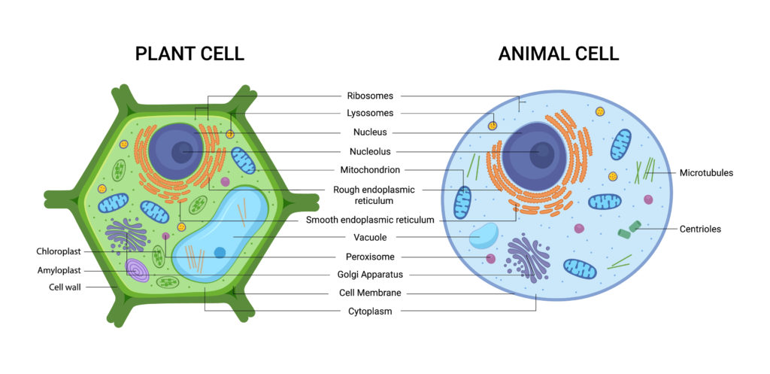  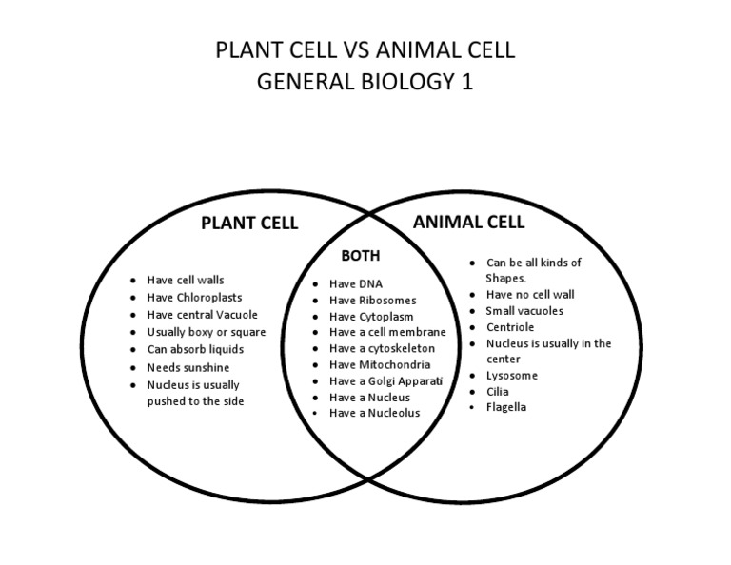  Part 3: Then students will watch a video about the endosymbiotic theory from Bozeman Science. While, and after, watching the video, they will fill out a thought catcher.  Students will then work with a shoulder partner to compare answers. |  |  | Lesson Look Fors  Look for teachers to:  - Monitor students’ progress through the 3 activities and ask probing questions that allow for on-the-spot formative assessment.  - Stamp for students that plant cells and animal cells are mostly similar except for a few organelles.  Look for students to:  - Completely finish their Gizmo before they start plant vs animal cells.  - Compare and contrast both types of cells.  - Fill out their video thought catcher and utilize their shoulder partner to ensure their answers are accurate and complete.  Students Do and Know  Closing Knowledge Gaps: Bozeman Biology Videos  Cellular Organelles  Cell Membranes  Endosymbiosis
  - Compare and contrast plant and animal cells.
  - Compare and contrast prokaryotic and eukaryotic cells.
  - Explain the process of endosymbiosis.
  - .Plant and animal cells are eukaryotic cells.
  - Plant cells have three main differences: chloroplasts, cell wall, and a large central vacuole.
  - Plant and animal cells have mostly the same organelles.
  - Endosymbiosis is the theory that contends that mitochondria and chloroplasts were at one time free-living prokaryotes.
Lesson #3: Plasma Membrane Structure |  | Date:
Objective  SWBAT: Create a model and explain the function of the parts of a semi-permeable, phospholipid bilayer.  Standards  B.5.C – investigate homeostasis through the cellular transport of molecules  Vocabulary  Semipermeable membrane  Phospholipid  Cholesterol  Cell (plasma) membrane  Protein  Carbohydrates  Hydrophobic  hydrophilic  Science Practices/Prerequisite Knowledge and Skills  - Obtaining, Evaluating, and Communicating Information  - Developing and Using Models  - Cell Structure  - Structure = Function  - Defend a claim with evidence/reasoning  Materials Needed  - Card sort cards  - Copies of student docs  - For every group: 50 cotton swabs, 1 rubber band, 2 pipe cleaners, 1 drinking straw, and scissors | Instructional Notes  Part 1: Student Video  - Students will watch a video (either by themselves or in community with their peers) on cell membranes.  - During, and after, they will fill out a thought catcher.  - When the video has concluded students will get together with a thought partner and compare notes.  Part 2: Cell Membrane Model  - Students will follow the directions in the “Modeling the Cell Membrane” document.  - They will use household materials (cotton swabs, rubber bands, pipe cleaners, and a drinking straw) to model the structure of a cell membrane.  - They will then answer questions based on their current model and how they could manipulate the model and/or add to their model for it to become more accurate (based on what they learned in the video).  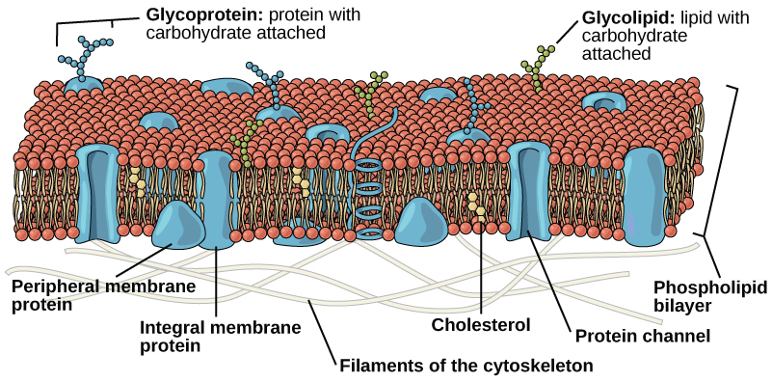 |  |  | Lesson Look Fors  Look for teachers to:  - Walk around the room asking probing questions that engage students to think deeper than just the model.  - Utilize accountable talk moves with their students (either one-on-one or as a group) so they don’t “give away” the answer but instead push students to come to the answer organically.  Look for students to:  - Ask clarifying questions throughout the activity.  - Defending claims with evidence and reasoning.  Students Do and Know  Closing Knowledge Gaps: Bozeman Biology Videos  Cellular Organelles  Cell Membranes  Endosymbiosis
  - Explain why the cell membrane is semi-permeable.
  - Explain why the cell membrane aids in the creation of homeostasis at the cellular level.
  - Identify the different parts of a cellular membrane and describe each of their functions.
  - .Homeostasis is keeping things the same (stable) or balanced.
  - The cell membrane allows for homeostasis to occur at the cellular level.
  - The cell membrane is semipermeable which means only certain things can get in and out.
  - The cell membrane is a phospholipid bilayer.
  - Each phospholipid has a hydrophilic end and a hydrophobic end.
  - The three biomolecules that are found in cell membranes are proteins, lipids, and carbohydrates.
Lessons #4 and #5: Biological Molecules |  |  | Date:
Objective  Day 4: Identify and describe the role biological molecules play in supporting cellular structure and function.  Day 5: Investigate the evidence from a murder scenario and use CER to defend the identity of a suspect.  Standards  B.5.A – relate the functions of different biomolecules, including carbohydrates, lipids, proteins, and nucleic acids, to the structure of a cell.  Vocabulary  Amino Acid  Carbohydrate  Glucose  Starch  Lipid  Protein  Nucleic Acid  DNA  RNA  Nucleotide  Monomer  Monosaccharide  Polymer  Polysaccharide  Phospholipid  Science Practices/Prerequisite Knowledge and Skills  - Asking Questions  - Developing and Using Models  - Analyzing and Interpreting Data  - Obtaining, Evaluating, and Communicating Information  - Structure = Function  - Defend a claim with evidence/reasoning | Instructional Notes  During Lessons 4 and 5, students will participate in an interactive activity where they test the stomach contents of a murder victim and decide, based on the presence of one of the four biological molecules, who the murderer is!  Day 4: Students will start with a quick video on how food is digested, then participate in a “think-write-share” activity. Then, they will use reagent tests to test for the presence of simple sugars, starch, proteins, and fats. Students will only be evaluating what “positive” results look like for each of the four tests.  Day 5: Students will use the techniques and the reagent tests they learned about during Day 5 to analyze the stomach contents of the murder victim. The murderer’s identity is determined by which biological molecule is present.  Productive struggle will be key during these two lessons.  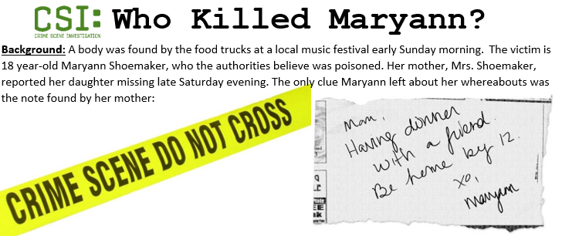 |  |  | Lesson Look Fors  Look for teachers to:  - Ensure that every student OR every group is engaged in the appropriate tests, with the appropriate techniques.  - Walk around the room asking probing questions related to the part of the simulation that students/groups are current on  - Facilitating both student-student and student-teacher discourse about the content.  Look for students to:  - Ask content-related questions throughout the lessons.  - Collecting data and analyzing it in order to make an appropriate conclusion.  - Defending a claim with evidence  Students Do and Know  Closing Knowledge Gaps: Bozeman Biology Videos  Cellular Organelles  Cell Membranes  Endosymbiosis
  - Identify the positive and negative results associated with reagent tests for the presence of different biological molecules.
  - Take data, analyze it, and make appropriate conclusions using claim, evidence, and reasoning.
  - The four biological molecules are carbohydrates, lipids, proteins, and nucleic acids.
  - Cells are made up of the four biological molecules.
  - Each reagent test has both positive and negative results.

Lessons #6 and #7: Viral Structure and Reproduction |  | Date:
Objective  SWBAT: Describe the structure of a typical virus and explain the main two ways in which it can reproduce.  Standards  B.5.D – compare the structures of viruses to cells and explain how viruses spread and cause disease.  Vocabulary  Virus  Lytic cycle  Lysogenic cycle  Disease  Cell membrane  Transcription  Translation  DNA  RNA  Protein  nucleus  Science Practices/Prerequisite Knowledge and Skills  - Asking Questions  - Developing and Using Models  - Analyzing and Interpreting Data  - Obtaining, Evaluating, and Communicating Information  - Cell Structure  - Structure = Function  - Defend a claim with evidence/reasoning  - Following a prescribed investigation  Materials Needed  - Access to Gizmos (computer with internet)  - Copies of Read to Learn  - Copies of Thought Catcher | Instructional Notes  Day 10: From AIDS to SARS to swine flu, viruses and the diseases they cause are a constant threat to our health. The Virus Lytic Cycle Gizmo allows students to see exactly how viruses infect healthy cells, produce copies of themselves, and then spread to other cells. The Student Exploration sheet contains two activities:  - Activity A – Students learn the stages of the lytic cycle.  - Activity B – Students analyze how a viral infection spreads through a population of cells.  Day 11: Students will have an opportunity to finish their Virus Lytic Cycle Gizmo from yesterday. Then they will utilize the rest of the day to investigate how viruses can spread from one person to the next. The students are prompted to watch a video about viral structure and their ability to spread, causing disease, while filling out a thought catcher (guided notes). Teacher then ends the lesson with a whole-group discussion (including student-student and student-teacher discourse) using the following questions:  - What are the parts of a virus?  - How do viruses make copies of themselves?  - Why don’t we call viruses alive?  - What does a virus usually do when it leaves the cell?  - What are some different ways in which viruses can be transmitted to another person?  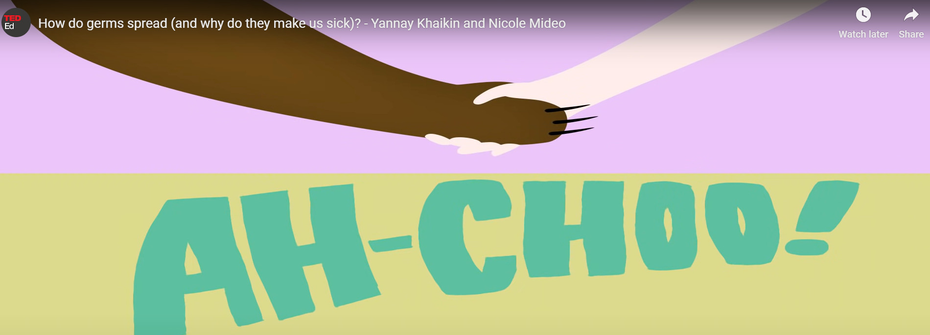 |  | Lesson Look Fors  Look for teachers to:  - Ensure that every student OR every group has access to a computer with an internet connection.  - Walk around the room asking probing questions related to the part of the simulation that students/groups are current on  - Facilitating both student-student and student-teacher discourse about the content.  Look for students to:  - Engage with the online simulation and fill out the thought catchers.  - Ask content-related questions throughout the lessons.  - Analyzing and/or manipulating models  - Collecting data and analyzing it in order to make an appropriate conclusion.  - Defending a claim with evidence  Students Do and Know  Closing Knowledge Gaps: Bozeman Biology Videos  Viruses  Viral Replication
  - Analyze a model of a viral reproduction cycle for similarities and differences with another viral reproduction cycle.
  - Take data, analyze it, and make appropriate conclusions.
  - Explain how a viral infection spreads over time.
  - Viruses are non-living.
  - Viruses can shut down our DNA and use our cellular machinery to create more viruses.
  - Viruses are just protein covered nucleic acids (DNA/RNA)

Day 8 | Flex Day
Day 9 | Review Day
Day 10 | Administer Unit Exam 1

UNPACKED STANDARDS
Focus standards for this unit.

Standards Clarification
Standards | Specificity | Notes/Explanations/Examples
B.5.A – relate the functions of different types of biomolecules, including carbohydrates, lipids, proteins, and nucleic acids, to the structure and function of the cell. | Cognition: Relate  Content: how the function of the biomolecules relates to the structure/function of the cell.  Standard Breakdown  - Relate the functions of different types of biomolecules [carbohydrates, lipids, proteins, and nucleic acids] to the structure of a cell  - Relate the functions of different types of biomolecules [carbohydrates, lipids, proteins, and nucleic acids] to the function of a cell  Major concepts in this standard include:  - Biomolecules (carbohydrates, lipids, proteins, nucleic acids) and their structure and function  - Polymers and monomers for each macromolecule  - Elements found in living things (C, H, O, N, P) and each biomolecule | When you teach this concept, remember to:  - Provide opportunities for students to associate biomolecules with varied macromolecules, subunits, and functions.  - Investigate ways that biomolecules support living things.  - Have students create models and use them to explain the functions of various biomolecules.  - Analyze the elemental components of biomolecules, where biomolecules are found in the body, and the metabolic processes biomolecules support.  Common misconceptions:  - Misidentifying the biomolecule’s function in the cell  - Misidentifying the elements that represent each biomolecule
B.5.B – compare and contrast prokaryotic and eukaryotic cells, including their complexity, and compare and contrast scientific explanations for cellular complexity. | Cognition: Compare/Contrast  Content: prokaryotic and eukaryotic cells, including their complexity  Cognition: Compare/Contrast  Content: scientific explanations for cellular complexity  This standard supports B.5(C) by providing cellular categories for organisms with or without a nucleus. It supports B.5(D) by providing overarching cellular categories for the comparison of viral organisms to cells. | When you teach this concept, remember to:  - Use a variety of models to show multiple representations of prokaryotic and eukaryotic cells.  - Provide opportunities for students to create models of prokaryotic and eukaryotic cells and use them to compare similarities and contrast differences.  - Explore multiple theories for cellular complexity (e.g., endosymbiotic theory and cell theory).  - Provide opportunities for students to model and associate the structure and function of organelles  Common misconceptions:  - Not recognizing that only eukaryotic cells have membrane-bound organelles  - Thinking that homeostasis does not occur in all cell types
B.5.D – compare the structures of viruses to cells and explain how viruses spread and cause disease | Cognition: Compare  Content: viral structures  Cognition: Explain  Content: how viruses spread and cause disease  Standard breakdown:  - Compare the structures of viruses to cells  - Explain how viruses spread disease  - Explain how viruses cause disease  Major concepts in this standard include:  - Viral structure vs. cellular structure  - Viral structure: capsid, nucleic acid, envelop, surface membrane proteins (attachment)  - Methods of viral transmission  - Viral disease: HIV, influenza, common cold, chicken pox, coronavirus, herpes, warts, etc. | Viruses depend on living organisms to grow and reproduce. Understanding the structure of viruses compared to cells relates to the overarching concepts of homeostasis and cellular processes. Comparing cells to viruses structurally and associating these organisms as living/nonliving supports further understanding of the basic structure of living things.  When you teach this concept, remember to:  - Vary the models, diagrams, and visuals to show the structure of viruses and cells.  - Provide students with opportunities to model and explain the similarities and differences between the structure of viruses and cells.  - Provide opportunities for students to analyze characteristics of viruses vs. cells.  - Differentiate how antibiotics affect bacteria vs. viruses.  - Relate the spread of viruses to real-world examples.  Common misconceptions:  - Not understanding the role of antibiotics and vaccines in treating/preventing disease  - Not associating cellular or viral structure with varied representations (image/model/list)

VERTCAL STANDARDS
This section details the progression of key student expectations/standards** in the courses before and after this course. This will help you understand what prior knowledge skills to build upon and guide you in knowing what skills you are preparing your students for in the subsequent course.

Biology Standard | Connections
B.5.A – relate the functions of different types of biomolecules, including carbohydrates, lipids, proteins, and nucleic acids, to the structure and function of the cell. | 6th Grade  - S.6.13.A – describe the historical development of cell theory and explain how organisms are composed of one or more cells, which come from pre-existing cells and are the basic unit of structure and function;  8th Grade Science  - S.8.13.A – identify the function of the cell membrane, cell wall, nucleus, ribosomes, cytoplasm, mitochondria, chloroplasts, and vacuoles in plant or animal cells;  AP Biology  - ENE-1.A – Describe the composition of macromolecules required by living organisms.  - SYI-1.B – Describe the properties of the monomers and the type of bonds that connect the monomers in biological macromolecules.  - SYI-1.C – Explain how a change in the subunits of a polymer may lead to changes in structure or function of the macromolecule.  - IST-1.A – Describe the structural similarities and differences between DNA and RNA.
B.5.B – compare and contrast prokaryotic and eukaryotic cells, including their complexity, and compare and contrast scientific explanations for cellular complexity. | 6th Grade  - S.6.13.A – describe the historical development of cell theory and explain how organisms are composed of one or more cells, which come from pre-existing cells and are the basic unit of structure and function;  8th Grade Science  - S.8.13.A – identify the function of the cell membrane, cell wall, nucleus, ribosomes, cytoplasm, mitochondria, chloroplasts, and vacuoles in plant or animal cells;  AP Biology  - SYI-1.D – Describe the structure and/or function of subcellular components and organelles.  - SYI-1.E – Explain how subcellular components and organelles contribute to the function of the cell.  - SYI.1.F – Describe the structural features of a cell that allow organisms to capture, store, and use energy.
B.5.D – compare the structures of viruses to cells and explain how viruses spread and cause disease | 6th Grade  - S.6.13.A – describe the historical development of cell theory and explain how organisms are composed of one or more cells, which come from pre-existing cells and are the basic unit of structure and function;  8th Grade Science  - S.8.13.A – identify the function of the cell membrane, cell wall, nucleus, ribosomes, cytoplasm, mitochondria, chloroplasts, and vacuoles in plant or animal cells;  AP Biology  - IST-1.O – Describe how the phenotype of an organism is determined by its genotype (retroviruses).  - IST-4.B – Explain how alterations in DNA sequences contribute to variation that can subject to natural selection.

VOCABULARY GLOSSARY
Domain-specific words and definitions for this unit.
Key Content Vocabulary
Amino acid – Amino acids are the building blocks of polypeptides and proteins and play important roles in metabolic pathway, gene expression, and cell signal transduction regulation. A single organic amino acid molecule contains two functional groups – amine and carboxyl – and a unique side chain. Humans require twenty different amino acids; eleven are synthesized in the body and nine obtained from dietary sources.

Carbohydrate – An organic compound is a compound that, in general, contains carbon covalently bound to other atoms, especially Carbon-Carbon (C-C) and Carbon-Hydrogen (C-H).

Lipid – Lipids are organic compounds that are readily soluble in nonpolar solvents (e.g., ether) but not in polar solvents (e.g., water). It is usually made up of glycerol or fatty acid units, with or without other molecules. Many lipids are amphiphilic, meaning they have both hydrophobic and hydrophilic components.

Protein – Proteins are biomolecules comprised of amino acid residues joined together by peptide bonds.

Nucleic Acid – Any of the group of complex compounds consisting of linear chains of monomeric nucleotides whereby each monomeric unit is composed of phosphoric acid, sugar, and nitrogenous base, and involved in the preservation, replication, and expression of hereditary information in every living cell

Adenine – A purine nucleobase that complementary pairs with thymine in DNA and with uracil in RNA

Cytosine – A pyrimidine nucleobase that complementary pairs with guanine in DNA and RNA

Guanine – A purine nucleobase that complementary pairs with cytosine in DNA and RNA

Thymine – A pyrimidine nucleobase in the DNA molecule that complementary pairs with adenine

Uracil – A pyrimidine nucleobase in the RNA molecule that complementary pairs with adenine

DNA – A helical double-stranded nucleic acid that is crucial for containing the genetic information for cell growth, division, and function.

RNA – A nucleic acid that is frequently single-stranded and folded onto itself, and composed of repeating nucleotide units of ribose sugar, phosphate group, and nitrogenous base

Hydrogen bond – A type of chemical bond that is formed when the slightly positive hydrogen atom of a polar covalent bond forms an electrostatic link with the more electronegative atom of a polar covalent bond in the same or another molecule

Hydrolysis reaction – The process of splitting a compound into fragments with the addition of water; a kind of reaction that is used to break down polymers into simpler units, e.g., starch into glucose.
Condensation reaction – a form of biochemical reaction wherein a water molecule is lost or removed from the reacting molecule resulting in the bonding of one monomer to another

Monomer – The word micromolecule refers to a small molecule of low molecular weight and is often referred to as a monomer. Monomers are combined together through different biochemical reactions to form a macromolecule, which is known as a polymer.

Polymer – A compound made up of several repeating units (monomers)

Nitrogenous base – The base in the nucleic acid, e.g., purines and pyrimidines

Nucleotide – an organic compound made up of a nitrogenous base, a sugar, and a phosphate group

Phospholipid – A lipid consisting of a glycerol bound to two fatty acids and a phosphate group.

Polysaccharide – Any from the group of polymeric carbohydrates formed by long chains of repeating units linked together by glycosidic bonds

Monosaccharide – A simple sugar that constitutes the building blocks of a more complex form of sugars such as oligosaccharides and polysaccharides; examples are fructose, glucose, and ribose

Eukaryotic cell – an organism that possesses a membrane-bound nucleus.

Prokaryotic cell – any organism that is chiefly characterized by a cell devoid of a well-defined nucleus as opposed to a eukaryote that has a nucleus. Instead of a nucleus, the prokaryotes have a nucleoid region where the genetic materials are located.

Mitochondria – A spherical or rod-shaped organelle with its own genome, and is responsible for the generation of most of the cell’s supply of adenosine triphosphate through the process of cellular respiration

Lysosome – Organelle containing a large range of digestive enzymes used primarily for digestion and removal of excess or worn-out organelles, food particles, and engulfed viruses or bacteria

Nucleus – the organelle inside the cell containing the chromosomes.

Ribosomes – cytoplasmic structure that is minute and sphere-shaped. It is composed of protein and ribonucleic acid (RNA). It serves as the site of protein synthesis.

Rough ER – one of the most prominent organelles of a eukaryotic cell. The ER occurs as an interconnected network of flattened sacs or tubules called cisternae. The membranes of the ER are connected to the outer nuclear envelope, and they may also extend into the cell membrane…typically found in cells producing proteins. (E.g., pancreatic cells, liver cells, goblet cells, and plasma cells).

Smooth ER – one of the most prominent organelles of a eukaryotic cell. The ER occurs as an interconnected network of flattened sacs or tubules called cisternae. The membranes of the ER are connected to the outer nuclear envelope, and they may also extend into the cell membrane… SER will be abundant in cells involved with the production of lipids (fats) and steroid hormones (e.g., adipose cells, interstitial cells, glycogen storing cells of the liver, conduction fibers of heart, spermatocytes, and leucocytes.).

Cytoplasm/Cytosol – The liquid component of the cytoplasm surrounding the organelles and other insoluble cytoplasmic structures in an intact cell where a wide variety of cell processes take place

Cell Wall – The membrane that surrounds the cell and separates it from the outside environment is the cell membrane whereas a cell wall is another structural layer surrounding the cell, next to the cell membrane. The main function of the cell wall is to give the cell rigidity, strength, and protection against mechanical stress.

Permeability – the ability of fluids to pass through materials

Plasma membrane – biological membrane that surrounds every living cells to separate the internal components from the outside. It guards the cell against the various external stressors or substances. It is composed of a phospholipid bilayer, proteins, lipids, carbohydrates, and other components.

Diffusion – net passive movement of molecules or particles from regions of higher to regions of lower concentration.

Passive Transport – transport of substances across a biological membrane from an area of higher concentration to an area of lower concentration without the help of a transport molecule

Facilitated Diffusion – transport of substances across a biological membrane from an area of higher concentration to an area of lower concentration with the help of a transport molecule

Active Transport – transport of substances across a biological membrane from an area of lower concentration to an area of higher concentration with the help of a transport molecule and energy

Osmosis – diffusion of water

Exocytosis – when materials leave the cell by the membrane “spitting it out”

Endocytosis – the cell membrane folds itself around the material to be engulfed resulting in the formation of a vesicular structure that eventually pinches off from the membrane inside the cell.

Tonicity – A property of a solution that depends on the osmotic force exerted across the membrane as influenced by the differing concentrations of solutes in and out of the cell; the osmotic pressure or tension of a solution, as in the cells would swell or shrink depending on the tonicity of the environment

Hypertonic – solution that contains a higher amount of solute as compared with the solute concentration in the other solution across a semipermeable membrane

Hypotonic – solution that contains a lower amount of solute as compared with the solute concentration in the other solution across a semipermeable membrane

Isotonic – solution that contains an equal amount of solute as compared with the solute concentration in the other solution across a semipermeable membrane.

Golgi complex – organelle that is comprised of membrane-bound stacks and is involved in glycosylation, packaging of molecules for secretion, transporting of lipids within the cell, and giving rise to lysosomes

Chloroplasts – refers to the organelle found within the cells of plants and other photosynthetic eukaryotes that is filled with the green pigment called chlorophyll.

Phospholipids – A lipid consisting of a glycerol bound to two fatty acids and a phosphate group

Hydrophilic – “water-loving”

Hydrophobic – “water-hating”

Polar – pertaining to a compound exhibiting polarity or dipole moment, which is a compound bearing a partial positive charge on one side and a partial negative charge on the other

Nonpolar – compound comprised of molecules linked through chemical bonds arranged in such a way that the distribution of charges is symmetrical (equal)

